***# WELCOME FORM :***



***//CODING FOR*** *LABEL(Click to continue.....)*

this.setVisible(false);

new Login().setVisible(true);

***# LOGIN FORM :***

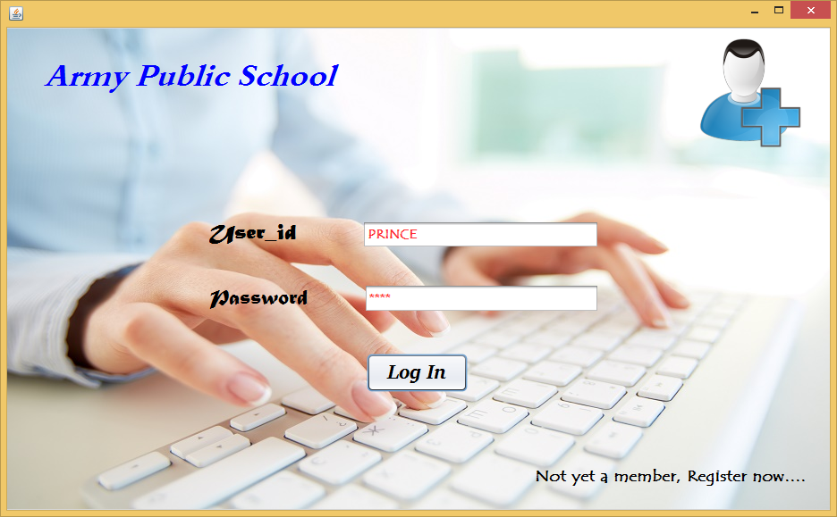

***\* If Log In Button is clicked :***

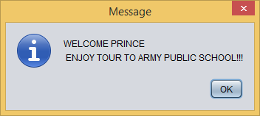

***# REGISTER FORM :***

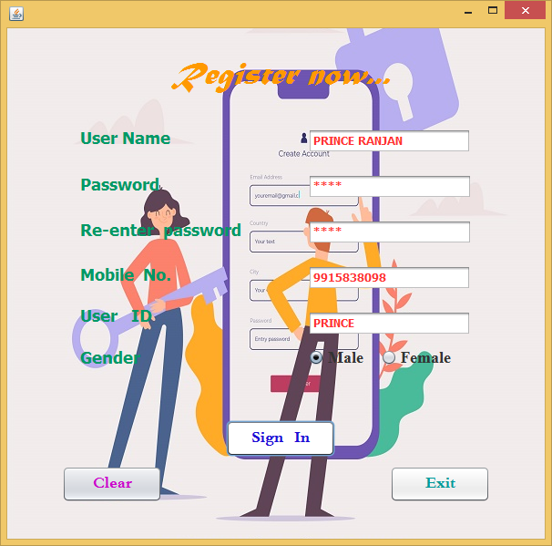

***\* If exit button is clicked :***

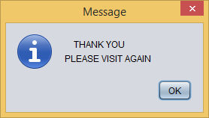

***\* If Password exceeds 4 digits :***

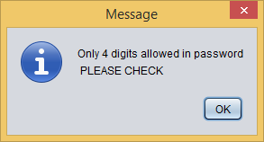

***\* If Username exceeds 25 characters :***

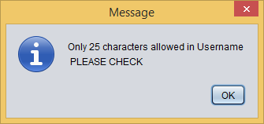

***\* If Password doesn’t match :***

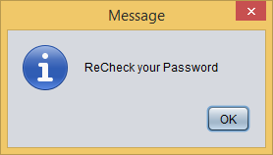

***\* If Mobile number exceeds 10 digits :***

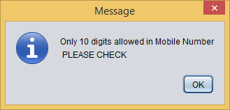

***\* If all fields are not filled:***

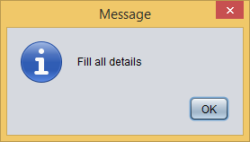

***\* If User id exceeds 35 characters :***

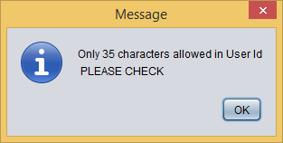

***# CHANGE FORM :***

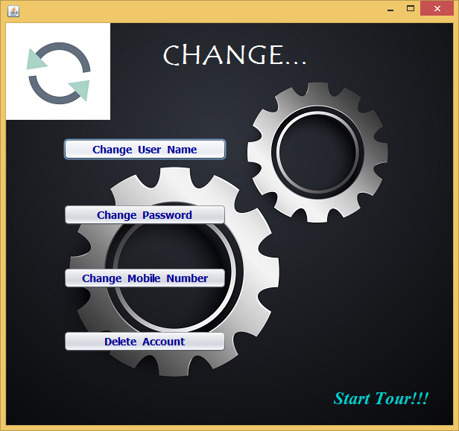

***# CHANGE USERNAME FORM :***

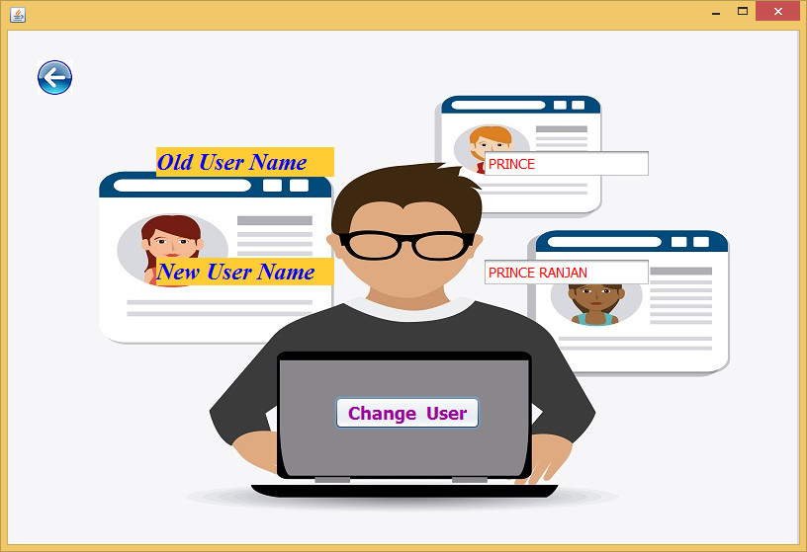

***\* If Change user button is clicked :***

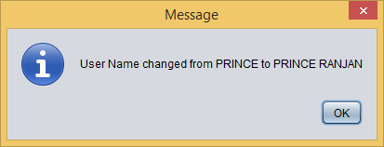

***# CHANGE PASSWORD FORM :***

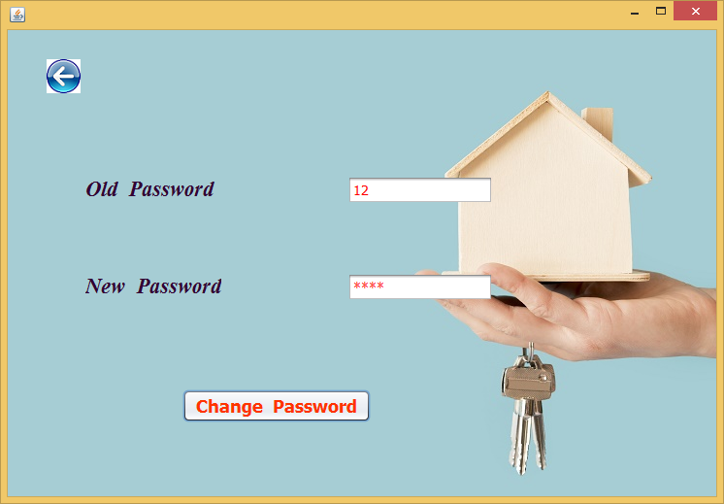

***\* If Change Password button is clicked :***

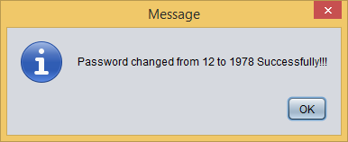

***# CHANGE MOBILE NUMBER FORM :***

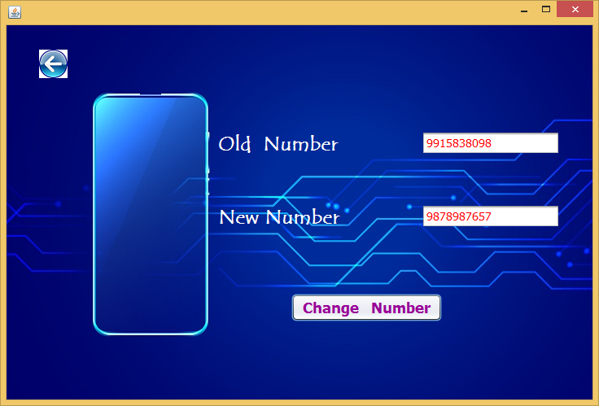

***\* If Change Number button is clicked :***

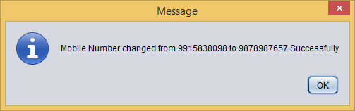

***# DELETE ACCOUNT FORM :***

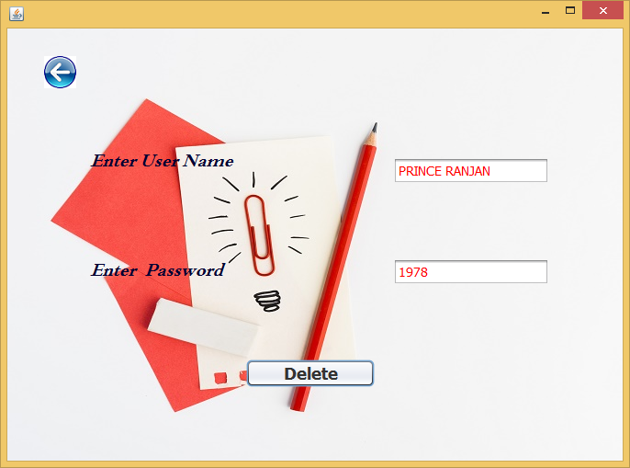

***\* If Delete button is clicked :***

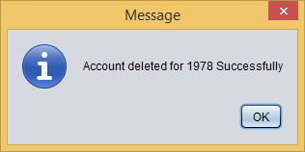

***# ARMY PUBLIC SCHOOL FORM :***



***//CODING FOR*** *LABEL(Enter to continue…)*

this.setVisible(false);

new Information().setVisible(true);

***# INFORMATION WINDOW FORM :***

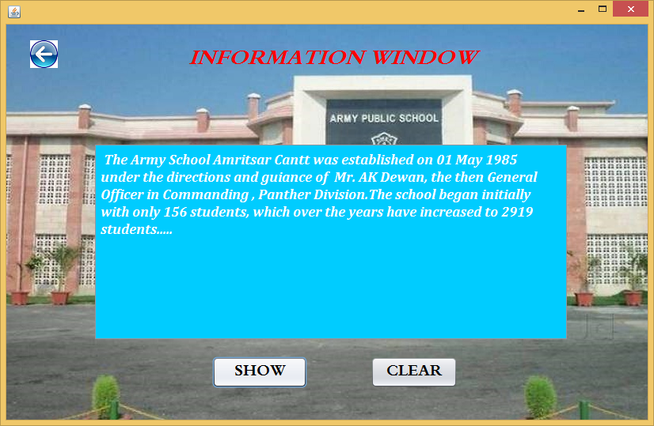

***# CONTENTS FORM :***



***# GUIDELINES FORM :***

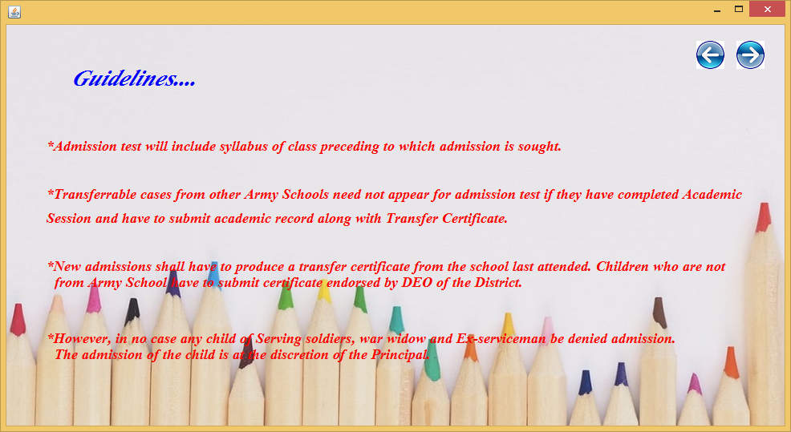

***# ADMISSION TEST(SUBJECTS)FORM :***

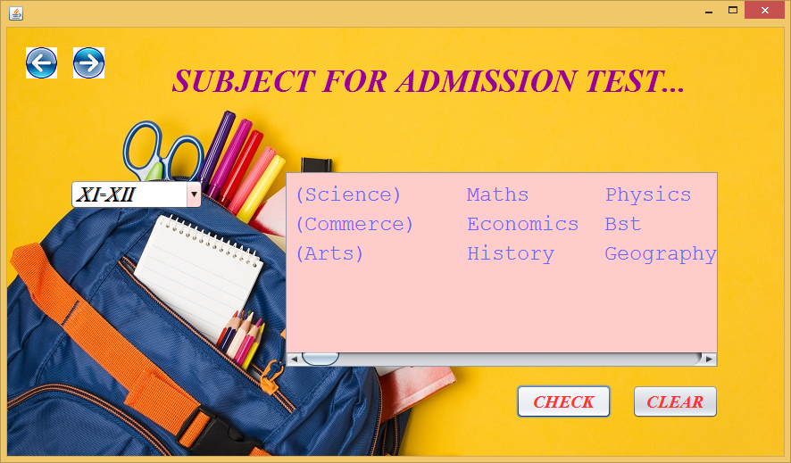

***# SUBJECTS OFFERED FORM :***



***# AGE CRITERIA FORM :***

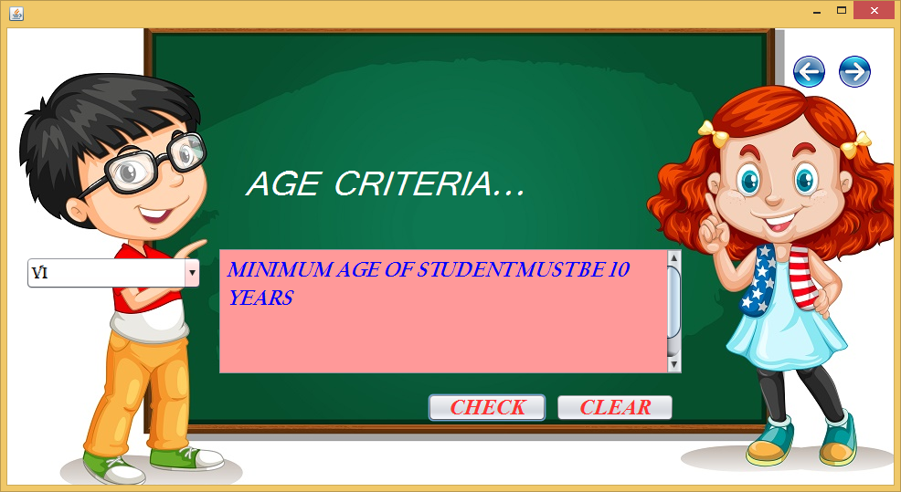

***# MARKS FOR ADMISSION FORM :***

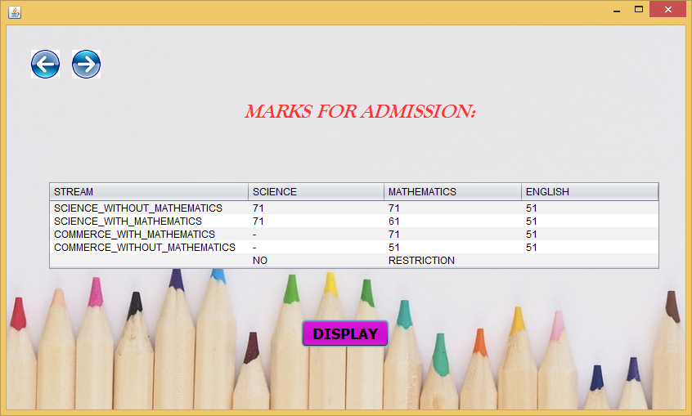

***# SCHOOL FACULTY FORM :***



***# STUDENT’S INFORMATION SYSTEM FORM :***

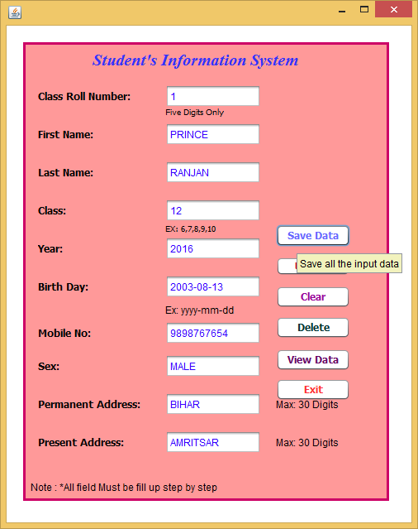

***\*If save data button is clicked :***

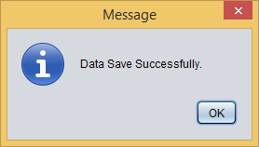

***# STUDENT’S DATA FORM :***

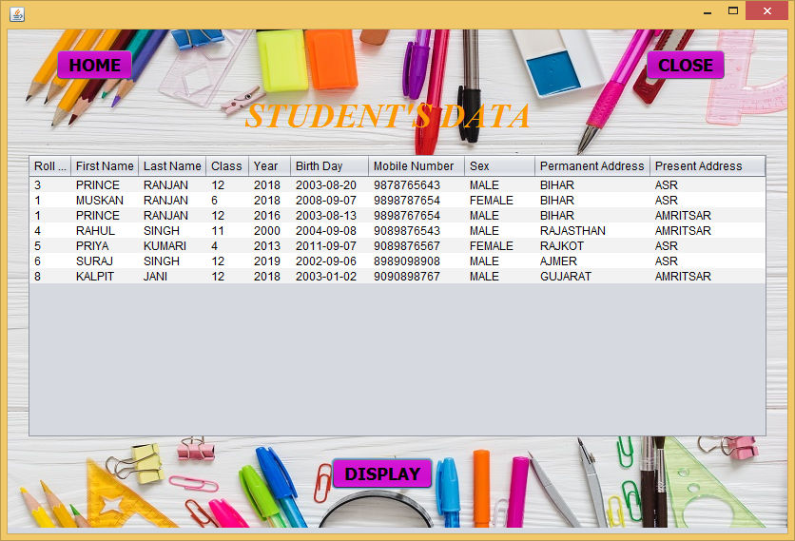

***# TEACHER’S INFORMATION SYSTEM FORM :***

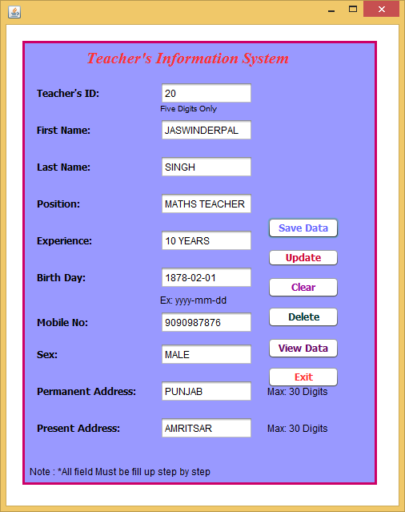

***\* If save data button is clicked :***



***# TEACHER’S DATA FORM :***

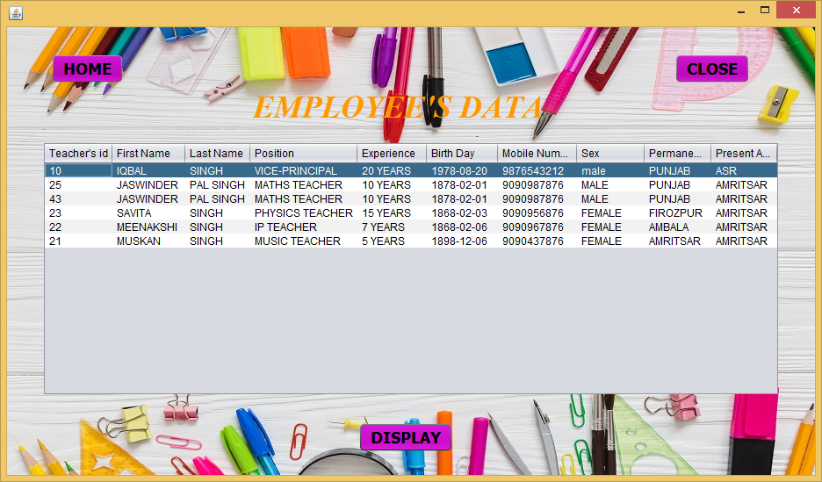

***# EMPLOYEE’S INFORMATION SYSTEM FORM :***

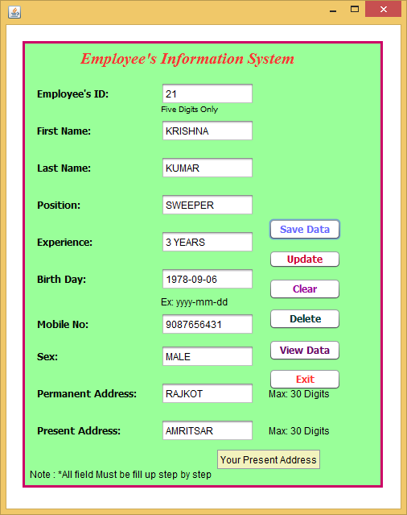

***\* If save data button is clicked :***



***# EMPLOYEE’S DATA FORM :***

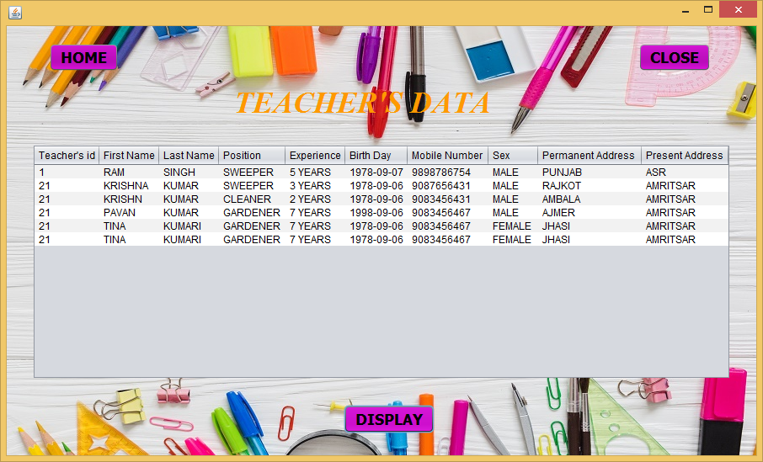

***# QUIZ 1 :***

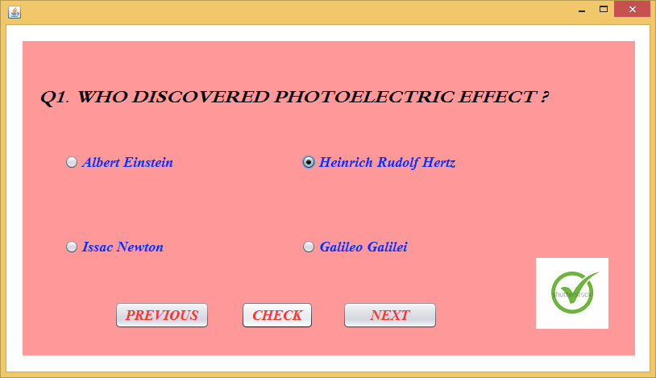

***# QUIZ 2 :***

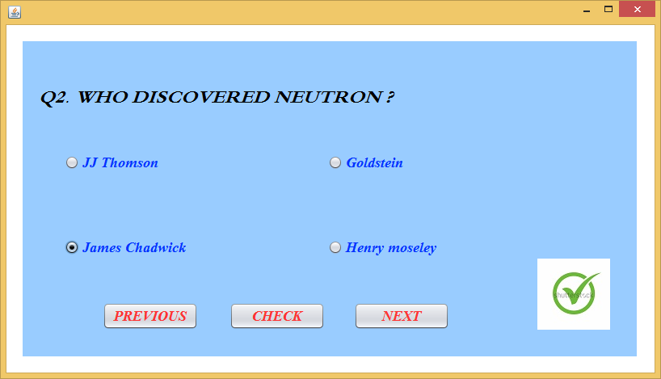

***# QUIZ 3 :***

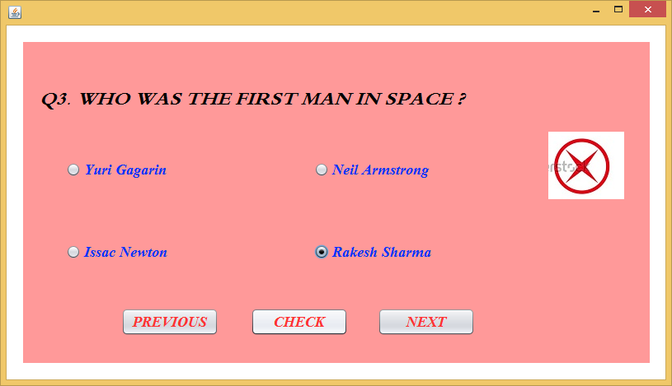

***# QUIZ 4 :***

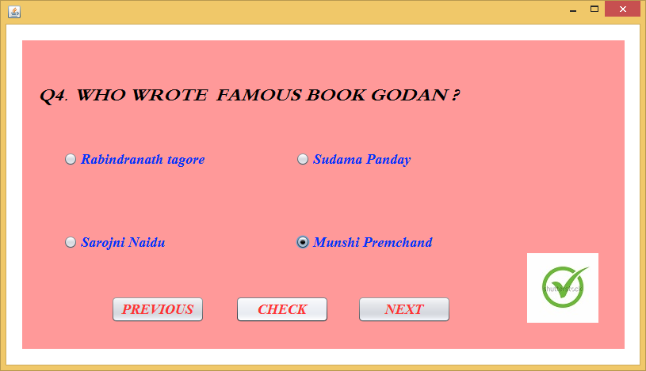

***# QUIZ 5 :***

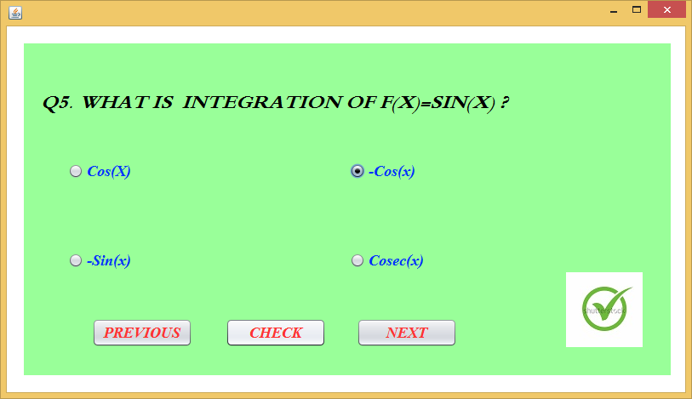

***# CONTACT FORM :***

